Lab # 2: Using DEBUGER
OBJECTIVE
The objective of this lab is to learn how to use debugger.
INSTRUCTIONS
First read Introduction section. Then perform the tasks given at the end of lab manual. You have to submit a report explaining what tasks you have performed and how. Do provide screenshots along with explanation for each task. The soft copy and hard copy of report must be submitted individually before next lab. No credit will be given on copied submission.
INTRODUCTION
Debug is a program supplied with both Windows and DOS to display the contents of memory and registers. It can be used to perform following functions:
- To assemble short programs.
- To view CPU registers and flags.
- To trace and execute short programs. By tracing a program means that program is executed one line at a time. The advantage of tracing a program is that you can easily monitor changes in variables and registers.
- To search binary or ASCII values in memory.
- To fill a block of memory.
- To move a block of memory from one location to another.
How to invoke DEBUG
To invoke DEBUG, open DOS window and enter the following command:
C:\> debug <enter>
OR
Click Start button, write debug in run prompt and press Enter Key.
DEBUG command responds with the hyphen - prompt. The hyphen prompt indicates that DEBUG is ready to accept commands in an interactive environment.

Using Mark and Copy Operation in DOS Window
To copy commands any text from MS DOS, Click the C:\ icon shown in title bar. To select text, use mark option and then drag mouse to select the text you want to copy. Then select the Copy option from the menu displayed after clicking the same icon as shown in following figure.
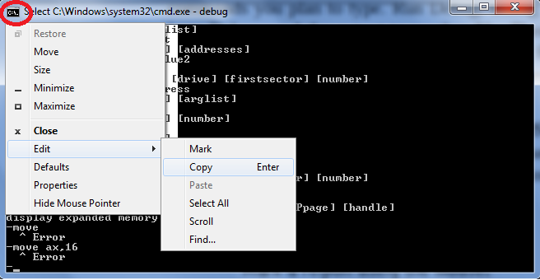
DEBUG Commands
- To get help type ? and press Enter key.
- To quit debugger, type q or quit and press Enter key.
- To examine the contents of register, type r and press Enter key. The command also displays flags and next instruction about to be executed. The possible formats for r command is given below:
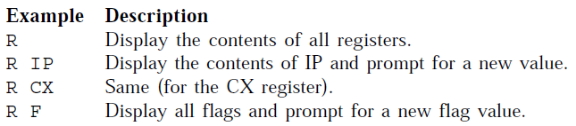

TASKS
- Show how you can invoke DEBUG.
- How can you display list of all valid commands? Also, show the list of commands displayed? What information is displayed in the list against each command?
- Show how you can execute r command in different formats.
- What is a register?
- What is the difference in registers and flags?
- Briefly explain the purpose of each register. For Example, ax (accumulator) is a data register used by CPU for arithmetic operations.

